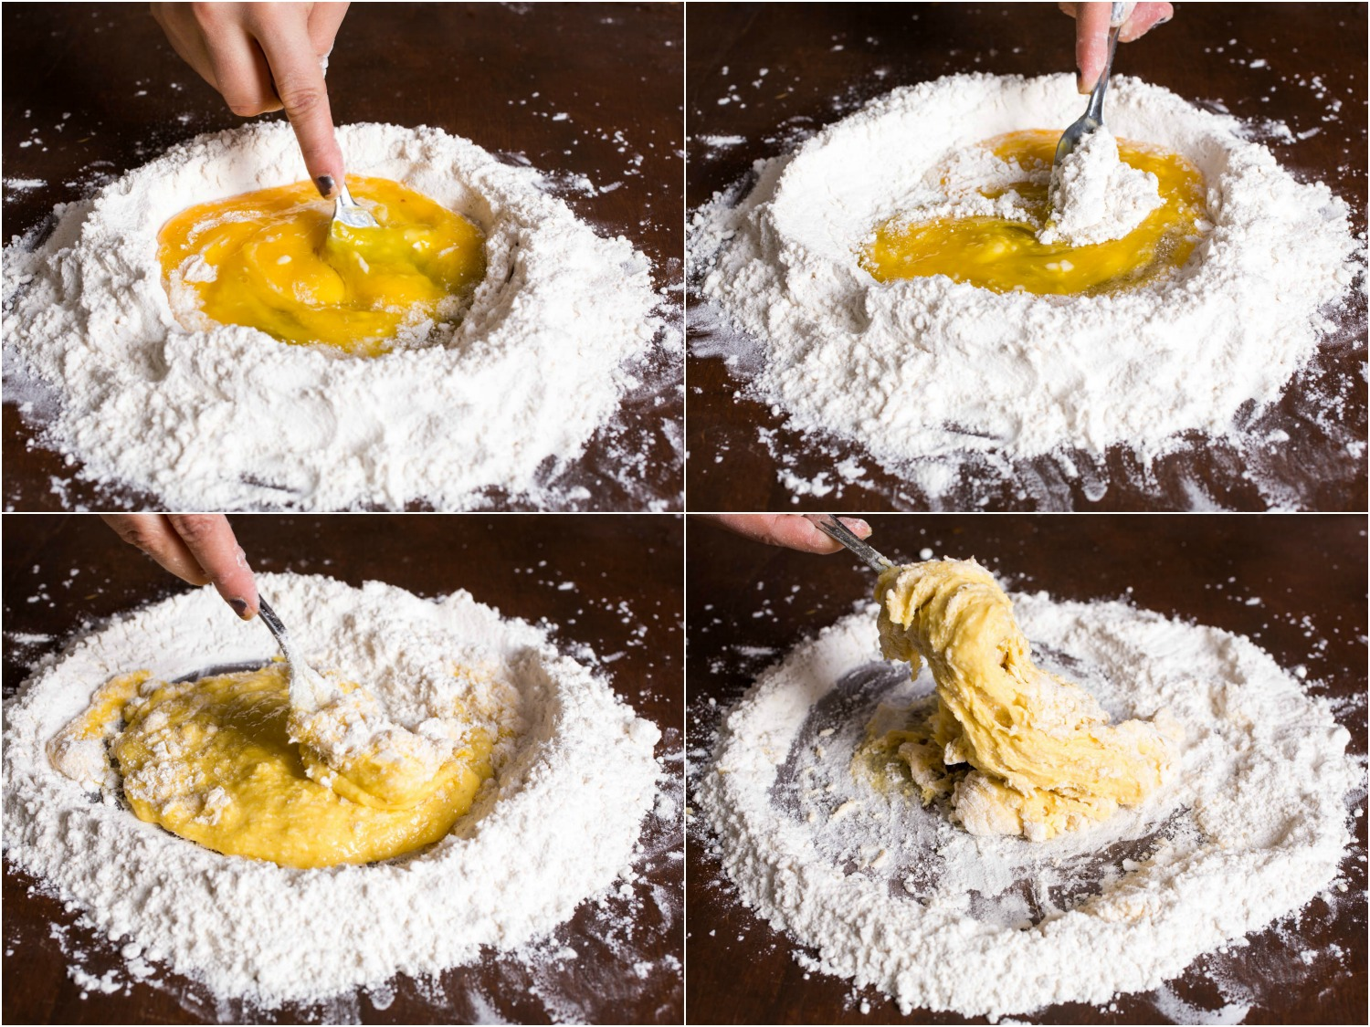
Part I: Pasta

Basic Pasta Recipe
2 cups flour
3 large eggs
½ tsp salt
½ tsp olive oil
Some add 1-2 tablespoon water as needed
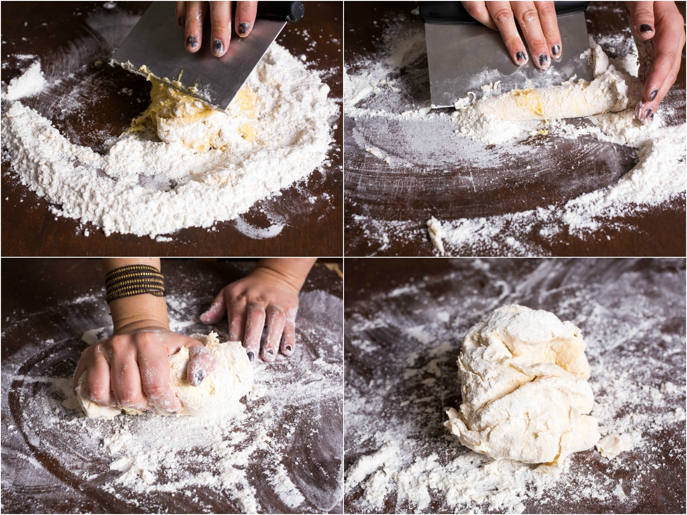
Make the dough
- Pour all flour and salt into a mound and make a well big enough to accommodate the eggs
- Add eggs and oil
- Use a fork to whisk in the flour “pond” then mix with fingers to push flour into the pool of egg, incorporating eggs/oil into flour until a single mass is achieved. Should be a moist “craggy-looking” ball. If too dry, add a little water or more oil.
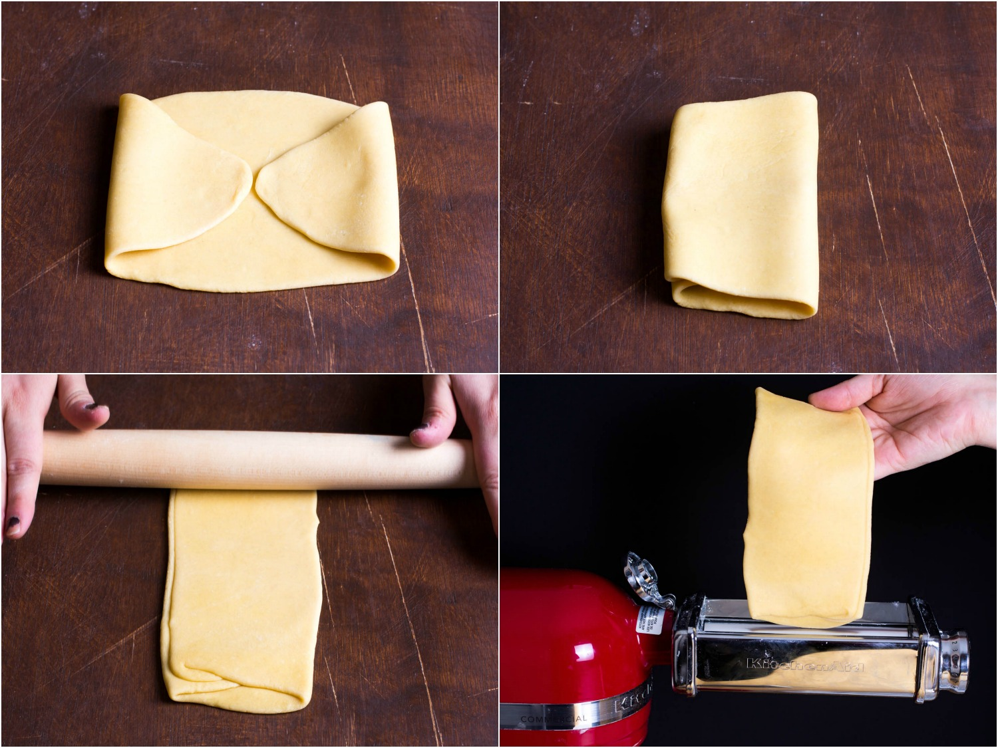
- Fold dough and begin to kneed. This is a TON of work and not easy. Minimum of 10 min to get a smooth tough ball of dough. Push the dough forward and down with the ball of your hand until the dough no longer looks powdery. It should be a firm and smooth elastic texture – like Play-Doh. If the ball is too wet or tacky, add more flour.
Then wish you had a stand mixer!!!
- Wrap the dough and let sit for 10-30 min.
- Start boiling the water with salt for cooking your pasta.
- Start making your sauce at this time.

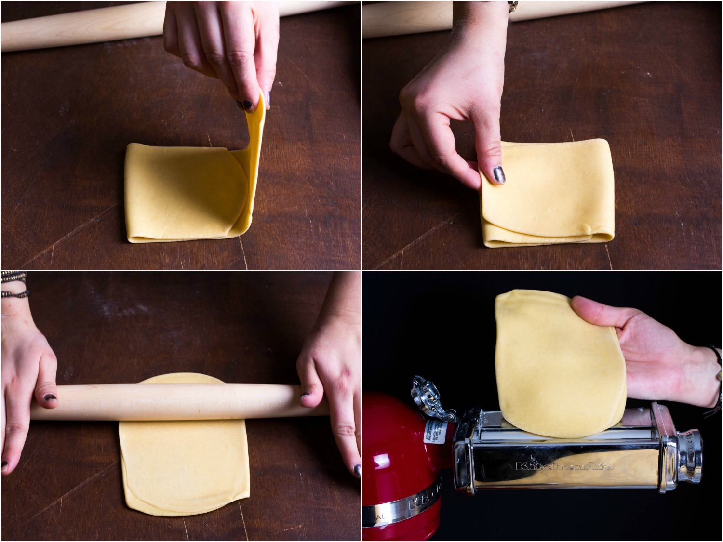
Rolling your pasta dough
- Cut the ball in 4ths and set the roller at the widest.
- Using the palm of your hand, flatten/roll the dough and put through the roller on the widest setting.
- Fold as instructed in the picture (think of a wallet) and re-roll at the same setting.
- Repeat a total of three times to laminate the dough.
- Reduce the number one each time until a “6 or 7” setting
- Cut the flattened dough in half or thirds, dust and set aside. Lightly dust with flour (very lightly).
- Change the dough roller for the wide cut fettuccine setting and make your noodles.
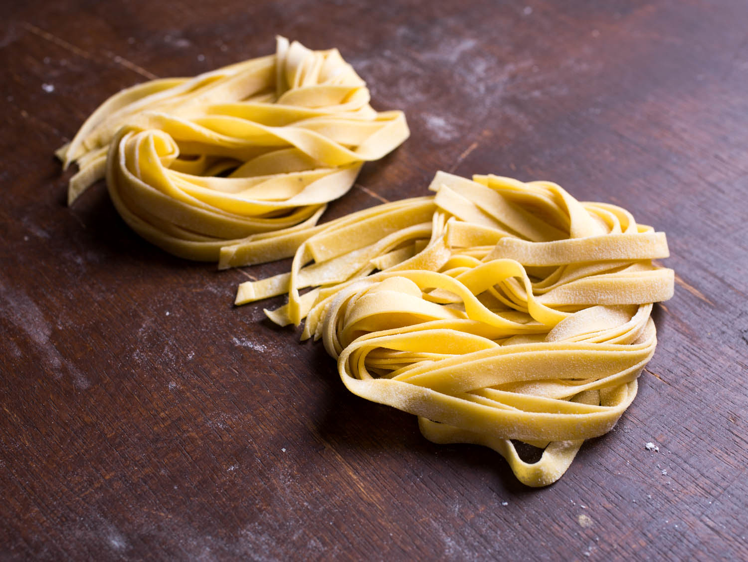
- Dust the parchment paper and your pasta and make a little nest.
- Boil 60-9-seconds and eat with your sauce!

Variables.
Flour – All Purpose, 00 (double zero) and seminoma
Hydration – egg white only, egg yolk only, water only
Resting – 0, 15, 30 min resting before rolling.

As a class, decide who will do the control – basic recipe (two groups minimum for n>1; we are not myth busters one and done!)
Then determine different alterations on the recipe using the science of flour dough to make your decisions.
Dough away!

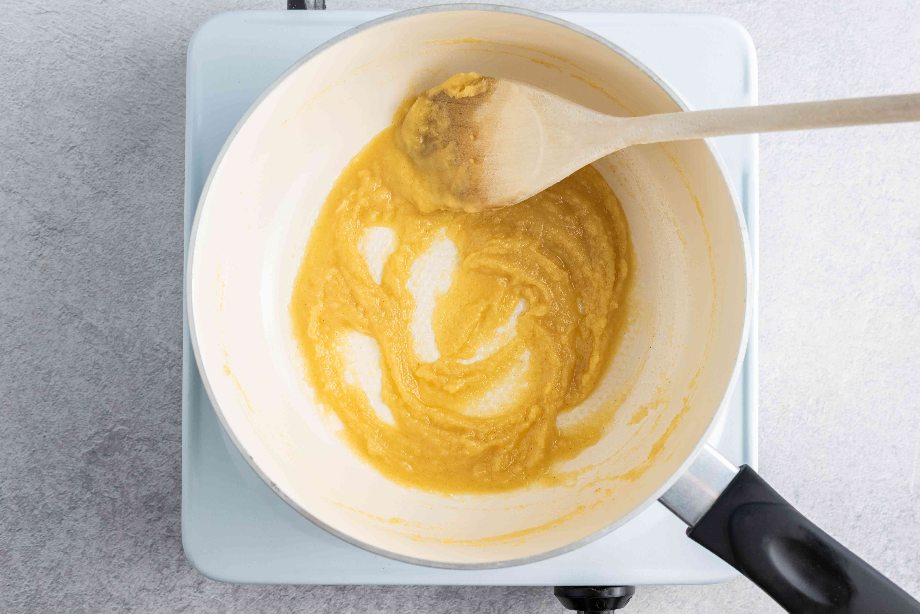
Béchamel Cheese Sauce (aka Mornay Sauce):

3 tablespoon butter
¼ cup all purpose flour
1 cup whole milk, warmed in microwave
¼ teaspoon salt
¼ cup grated cheddar cheese (real Mornay sauce uses Gruyere and Parmesan)
1 tablespoon fine grated parmesan cheese
Salt, pepper and nutmeg to taste
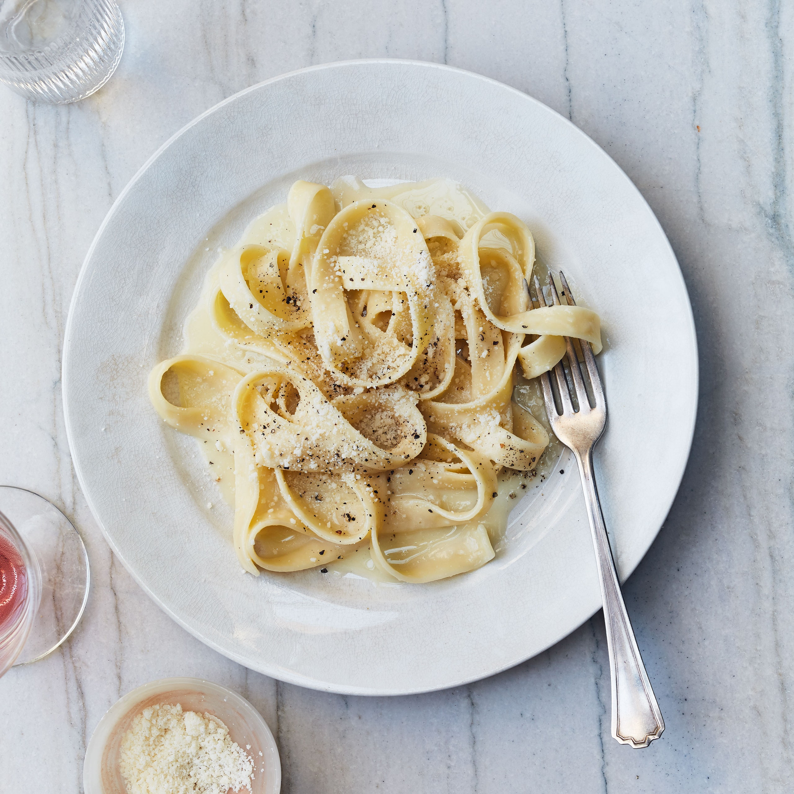
Use Med-Low heat (150-200oC.300-400oF) to melt butter, then add flour and cook until water has boiled off.

Cook for 1-2 min for a blond roux while stirring

Slowly add warmed milk a little at a time while whisking continuously. 10-20 min.

Add salt, pepper, nutmeg, hot-pepper to taste.

Slowly stir in cheese and stir while melted.

EAT WELL

